Setting up Your AYUDA TeamRaiser Page

A few tips:
- Once you are set up, don’t forget to bookmark!
- Use the social marketing tools to get your page our there
- Don’t forget to keep it personal!!

Register

Step 1: Please click on the link of your program below to get started.
Campo Amigo
En El Camino

PLEASE NOTE: If you are going to both programs, register for Campo Amigo and set your fundraising goal accordingly.

Step 2: Set your fundraising goal. For each program, there is a suggested fundraising goal – which is the required amount you need to be raising. If you’re motivated feel free to set your goal higher!

Step 3: Select what type of User you are. If you have never created a page with AYUDA before, please select “New User”. If you have registered with us on Team Raiser before, you can select “Returning User” to log on and create your new page.

Click Next Step.

Step 4: Fill out your registration information completely and select a username and password that you can easily remember. If you lose your password, you can email Arianna at atuomey@ayudainc.net reset your password.

Step 6: Registration Complete! Now click on the “Access your Volunteer Center” link to set up your personal page. You can bookmark this page, or can access your volunteer center through the homepage of the e-course with your login information.

Set Up Your Personal Page

Step 1: From the Volunteer Center Homepage, click on the instructions in the Yellow Box “What to do next?” to set up your personal page. 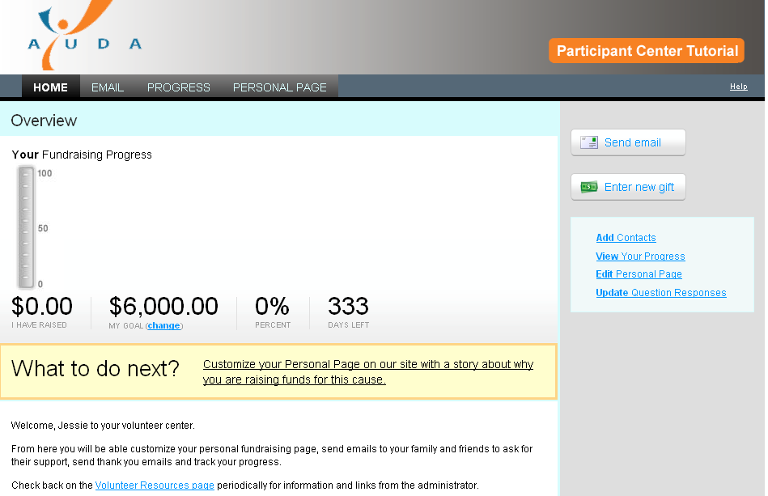

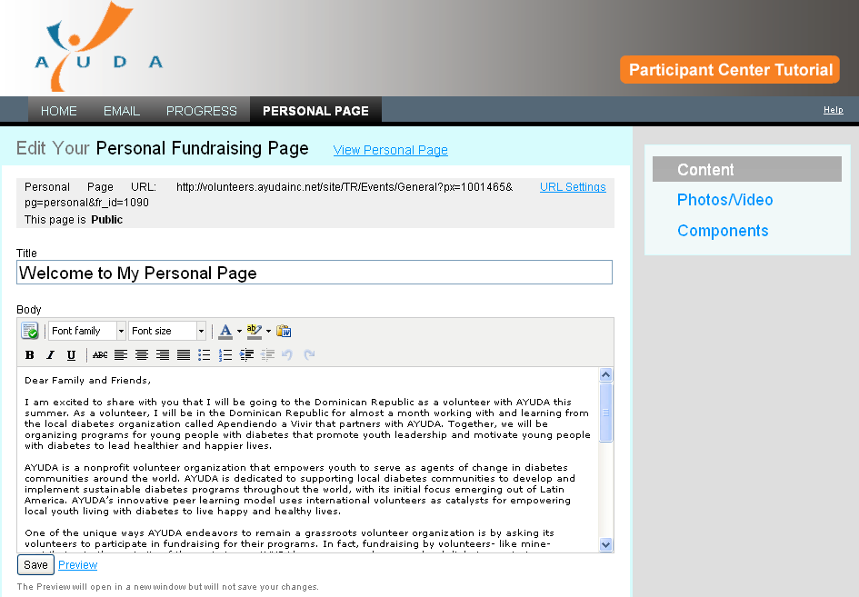
Step 2: Personalize your content. There is standard text describing your trip this summer, but we strongly encourage you to personalize it. When you are editing this content, please remember to save often! If you are prone to forget to save, create the text first in a Word doc or Text editor and copy and paste. People who don’t save work can lose it due to platform timeouts which is a huge bummer and waste of precious fundraising time!

Step 3: Photo/Video. You may select either a video or photo on your page. There is a standard AYUDA photo and video already uploaded on the page. We strongly recommend you personalize this as well.

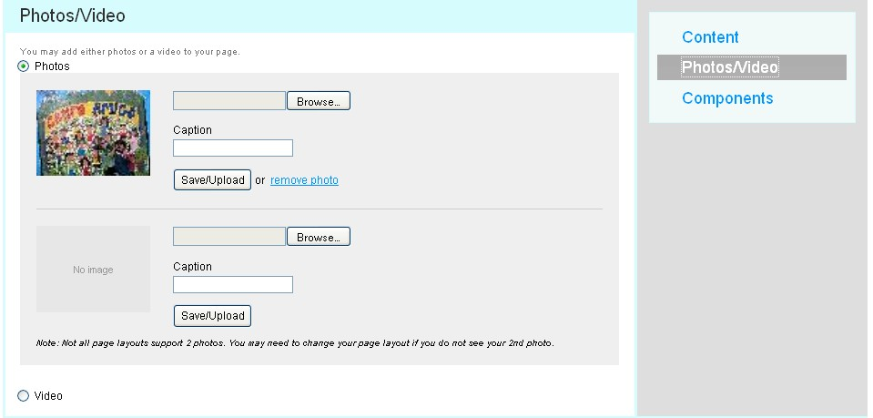
Step 4: Components. Here you may select which components you would like included on your personal page. We selected each of these components as tools to enhance your page, so we recommend you select all three.
  - Status Thermometer: Shows how close you are to reaching your fundraising goal
  - Fundraising Honor Roll: A scrolling record of all of those who have donated - will show up to 100 donors. To can chose to show names only, or names and amounts (by clicking on the box)
  - Personal Blog: If you select this you can keep a blog that updates your viewers on your campaign and trip progress
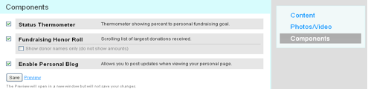
Step 5: Personalize your URL. You can edit your page URL to make it more user- friendly. To do this, just click on the “URL settings” button next to your existing URL in your personal page editor. We recommend making the URL something that’s short, easy to remember and personal – like your name or nickname.
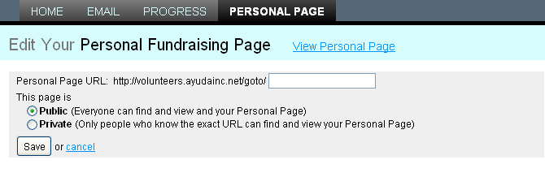
To view a sample personal page, please view these links.

http://volunteers.ayudainc.net/site/TR?px=1053676&pg=personal&fr_id=1232
http://volunteers.ayudainc.net/site/TR?px=1053369&fr_id=1231&pg=personal

Step 6: Send your URL and a photo to AYUDA so we can share your TeamRaiser page on our website. Send an email to Arianna with your URL and a photo (with a clear image of your face size 150 px X 300 px). Taking this step means that you have updated the content of your TeamRaiser page and are happy with the draft you have created. Once we have the URL, we will review it, in coordination with your VMs and get back to you with edits to really help your page sing! On ready, we add you to the Volunteer Look Up page on our website. This means your page will officially go “live” and anyone can search it from the AYUDA site to donate to you.

Step 7: Integrating your page into social networking applications. To share on Facebook, all you have to do is click the Facebook icon found on the right-hand side of your personal page editor. Or, from the “front end” of your personal page (the public side), you can simply scroll down to the bottom of your personal page, and click on the “Share tab”.

Select the application you would like to share your page with and follow the instructions.

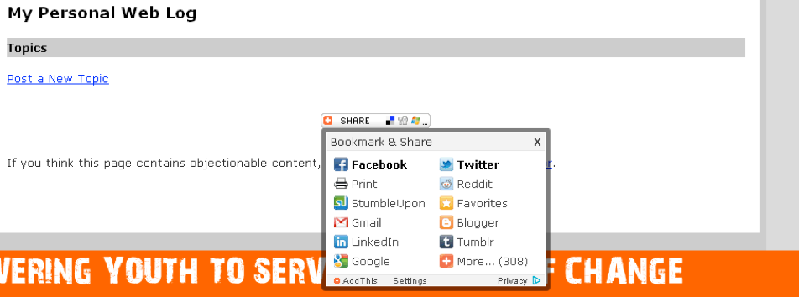

Donations

Through your personal page, people can make donations directly to AYUDA. Once a donation is made online you will be notified via email. You can also see your donation progress using the “Progress” Tab or by clicking on a specific contact in your database. If you selected the Fundraising Honor Roll, donations will be listed on your personal page.

You can also enter offline donations directly (cash or check donations, not made by credit card or sent directly into our offices) into your TeamRaiser page using the “enter new gift” button the right-hand menu of the Volunteer Center homepage. If you are planning on doing this, please notify Arianna prior to doing so that we can ensure accounting is on board.

Once donations have been made online, donors will automatically receive a “thank you” autoreply from AYUDA. However, we strongly suggest you also send a personal thank you to each of your donors. If they donated online, you will see their email address in your Volunteer Center. Need help with your words? We’ve created a “thank you” template (see “Sending Emails” below).

Sending Emails
You can send personal emails to solicit donations, thank people for donations or update people on your progress via your Volunteer Center. The great part about sending emails through your Volunteer Center is it keeps track of all the activity of each email address – from the first email you send to through donations.

You can access your email by either clicking on the “Email” tab at the top of your editor on from your Volunteer Center homepage. To send emails you can either import contacts from Gmail or other services such as outlook, or add contacts in manually. Once someone’s email is in the “contacts” section you can track all of the emails you have sent to them, find out if they have opened the emails or clicked on your page and if they have sent a donation. Very handy!

If you are creating your very first email request for donations, AYUDA has created an email template you can use called “Please Support Me.” If you would like to use this email template as a guide for your message, please click on “Use Template” under the subject line. We again highly recommend you personalize it! There is also a thank you template.

If you are sending an email to many people at the same time, but still want to include a unique name in the salutation, select the check box “include a personal greeting” in the top of the edit bar.

Delete the “Dear” from your email (it’s included in the personal greeting. To see the email before it goes out click “Preview”. Each email will then include the name of your contact (so long as you have included a first and last name with each contact email that is entered into your contact database).

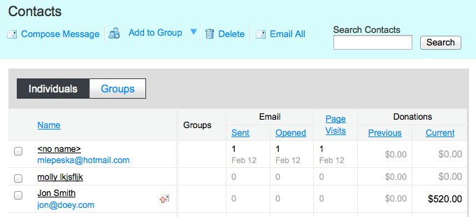

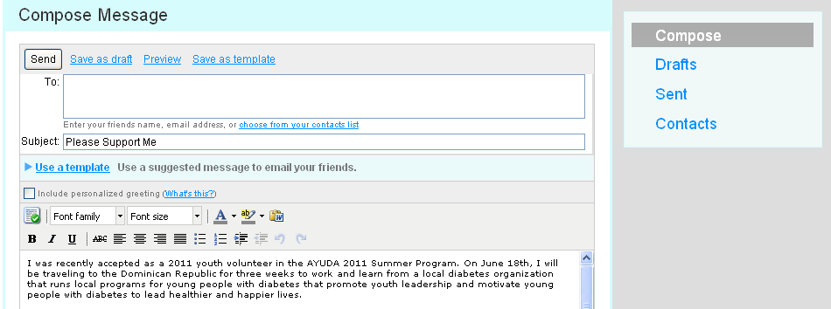
Once you send out your emails you can track all your potential donors simply by click on the Contacts button. There, you will see how many of the emails you sent were opened and clicked on by contact and also how much was donated per email.

